THE FEAST OF ALL SAINTS  Sunday 1st November 2026  Welcome to church!  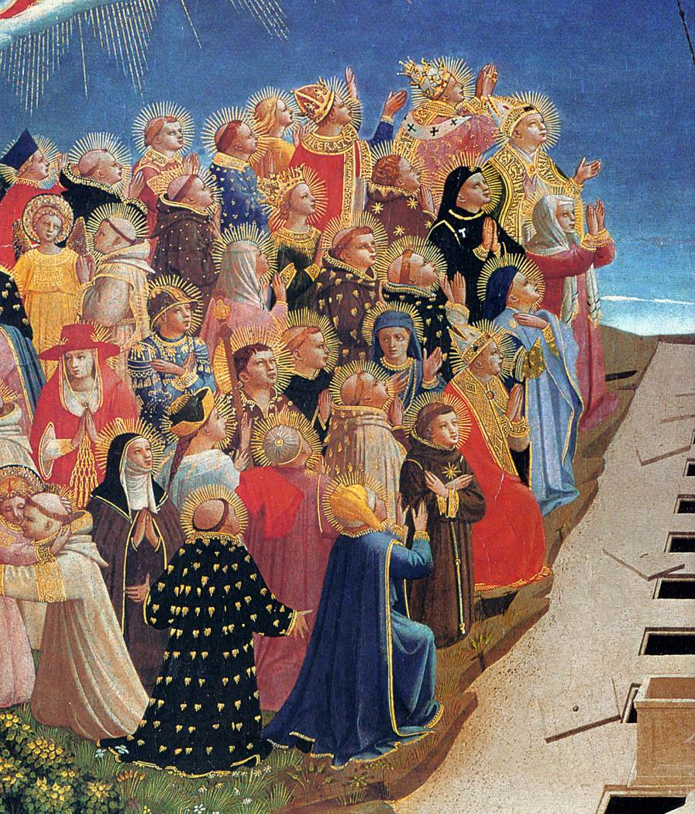  Hymns are in the NEH:  197, 381, 208, 478  Gluten free hosts are available from the station by the Lady Chapel | 
Today there will be a PCC meeting after church at 11.30am.
Tomorrow, Monday 2nd November, we celebrate All Souls Day with mass at 7.30pm. Please put down the names of any loved ones you would like read in the service. You can also buy a 7-day lamp for £8 to burn in the sanctuary. We would welcome donations towards singers for the Faure Requiem. We’re hiring four singers and each one costs £75. Everybody is welcome to come and sing. Please come for a rehearsal at 6.
Remember, remember! On Thursday 5th November we will be having a small bonfire with sparklers, hot dogs, and drinks after the 7pm mass. (Veggie options provided).
Book club continues! We are reading Story of a Soul by St. Thérèse of Lisieux, and will be meeting again in the vicarage on Monday 9th November, 7pm. Please read up to the end of chapter 8.
On Saturday 14th November at 7pm we’re holding a Gospel Concert to raise money for the church. Tickets £15 (£10 concession). If anybody can help with refreshments please speak to Vilma. We also need raffle prizes.
If you have a key to the church, please let Helen know so she can keep an accurate key register.
This Week
All services are at Holy Innocents unless stated

Monday 2nd November. All Souls.
7.30pm Solemn Requiem Mass for the departed

Tuesday 3rd November
9.30am Little Innocents Stay and Play
7:30pm Mass at Holy Trinity
Wednesday 4th November: St Charles Borromeo
10:00am Mass with prayers and anointing.
10.30-11.30 Coffee Morning

Thursday 5th November
7.00pm: Mass

Friday 6th November
10.00am Mass at Holy Trinity

Saturday 7st November
10.00am Mass with Prayer Circle

Sunday 8st November, 32nd Sunday in Ordinary Time: Remembrance Day.
10:00am Sung Parish Mass

PLEASE PRAY FOR
Those who are sick, including Maurice, Fr Luke, Delroy, Natalie, Margaret, Hector, Linnette, Darren, Doris, Sandra, Thomas, Nafissa, Bonnie and Malachi.
Those who have recently died, including Barbara Edwards, Melissa, Sola Adekoya, Gary Taylor, Ali, Tony Vineall.
Those whose anniversaries of death fall at this time including Ursula Reines, Ena Alford, Trevor Williams.

If there is someone you would like us to pray for, please speak to Brenda or email her on brenda.barwick01@btinternet.com.
CONTACT US
Fr Ben Kerridge Vicar 020 8340 1300 frben.holyinnocents@gmail.com The Vicarage, 99 Hillfield Av, N8 7DG
Mthr. Patricia Curate 07542 551602 mthrpatricia@holyinnocentshornsey.co.uk
Mthr. Sofia, Curate 07767 795607. curate@holyinnocentshornsey.co.uk
Brenda Barwick Lay Reader 020 8340 5382 brenda.barwick01@btinternet.com
Yvonne Westcarr Treasurer 07877403439 bookings@holyinnocentshornsey.co.uk
Website:www.holy-innocents.org.uk Facebook: www.facebook.com/HolyInnocentsN8 Instagram: holyinnocents4

