28th Sunday in Ordinary Time  Sunday 11th October 2026  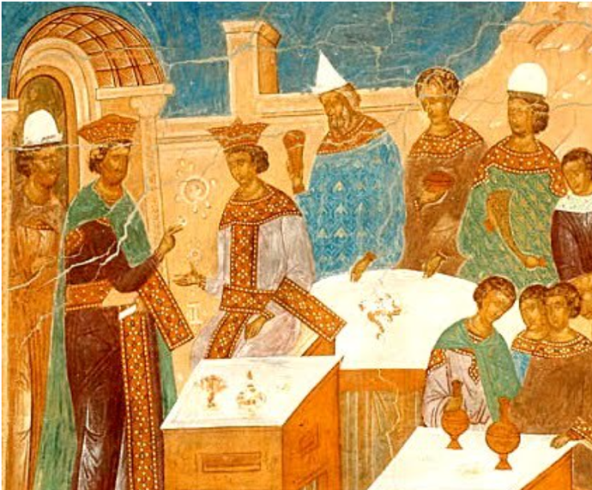  Welcome to church!  Hymns are in the Celebration Hymnal  43, 339, 84, 901  Gluten free hosts are available from the station by the Lady Chapel | 
Today is Mthr Patricia's last Sunday before she goes to be interim priest at All Saints' Edmonton. Our prayers go with her and she will be much missed. Please do stay for a piece of cake and a cup of tea. We are also celebrating Faye’s birthday.
Last call for the day trip to the Shrine of Our Lady of Walsingham! Please speak to Brenda if you’d like to join. Tickets cost £35 + £15 for lunch if you would like it. Please pay the remaining balance today.
On Friday 16th October at 7pm, Holy Trinity are hosting their annual parish quiz. The cost is £10 including supper. Book via info@holytrinitystroudgreen.org.uk.
We’ll be opening up the church for trick or treaters on 31st October from 5-7.30, so people can light a candle. We could do with a couple of volunteers to help with hot chocolate and refreshments.
On Monday 2nd November we celebrate All Souls Day with mass at 7.30pm. Please put down the names of any loved ones you would like read in the service. You can also buy a 7 day lamp for £8 to burn in the sanctuary. We would welcome donations towards singers for the Faure Requiem. We’re hiring four singers and each one costs £75. Everybody is welcome to come and sing. Please come for a rehearsal at 6.
Remember, remember! On Thursday 5th November we will be having a small bonfire with sparklers, hot dogs, and drinks after the 7pm mass. (Veggie options provided).
Book club continues! We are reading Story of a Soul by St. Thérèse of Lisieux, and will be meeting again in the vicarage on Monday 9th November, 7pm. Please read up to the end of chapter 8.
We are holding two concerts before Christmas, on 25th October at 5pm solo Bach suites with Gamaliel Rendle Traynor and on Sunday 29th November at 3pm Music for Advent with Nina.

This Week
All services are at Holy Innocents unless stated

Monday 12th October
10.00am Mass

Tuesday 13th October, St Edward the Confessor
9.30am Little Innocents Stay and Play
7:30pm Mass at Holy Trinity
Wednesday 14th October
10:00am Mass
10.30-11.30 Coffee Morning

Thursday 15th October, St Teresa of Avila, Virgin and Doctor of the Church
7.00pm: Mass

Friday 16th October
10.00am Mass at Holy Trinity

Saturday 17th October, St Ignatius of Antioch
Parish trip to Walsingham; no mass at Holy Innocents.

Sunday 18th October, 29th Sunday in Ordinary Time
10:00am Sung Parish Mass.
5.00pm Contemplate
PLEASE PRAY FOR
Those who are sick, including Maurice, Fr Luke, Delroy, Natalie, Margaret, Hector, Linnette, Darren, Doris, Sandra, Thomas, Nafissa, Bonnie and Malachi.
Those who have recently died, including Barbara Edwards, Melissa, Sola Adekoya, Gary Taylor, Ali, and Doreen.
Those whose anniversaries of death fall at this time including Icilda Cope, Daphne John, Norah Moss.

We are re-starting our list of intercessions to make sure it’s up to date. If you would like to re-add anyone to the list or add anyone new for us to pray for, please speak to Brenda or email her on brenda.barwick01@btinternet.com.

CONTACT US
Fr Ben Kerridge Vicar 020 8340 1300 frben.holyinnocents@gmail.com The Vicarage, 99 Hillfield Av, N8 7DG
Mthr. Patricia Curate 07542 551602 mthrpatricia@holyinnocentshornsey.co.uk
Mthr. Sofia, Curate 07767 795607. curate@holyinnocentshornsey.co.uk
Brenda Barwick Lay Reader 020 8340 5382 brenda.barwick01@btinternet.com
Yvonne Westcarr Treasurer 07877403439 bookings@holyinnocentshornsey.co.uk
Website:www.holy-innocents.org.uk Facebook: www.facebook.com/HolyInnocentsN8 Instagram: holyinnocents4

