Harvest Festival  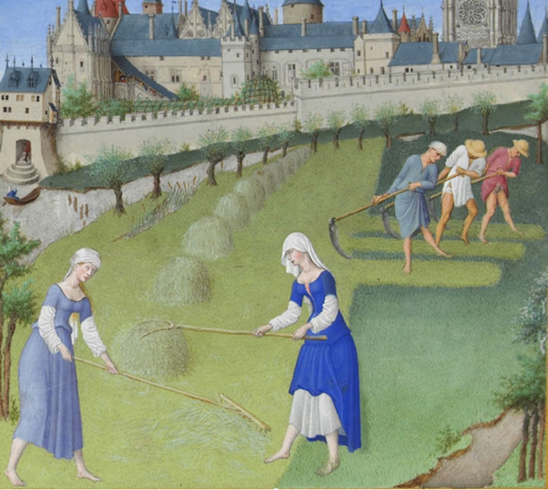  Sunday 4th October 2026  Hymns are in the Celebration Hymnal  136, 15, 178, 782  Gluten free hosts are available from the station by the Lady Chapel | 
A big thank you to everyone who helped out with the Autumn Fair, both with preparations and on the day!
Do join us for Contemplate this evening: 30 minutes’ prayer before the Blessed Sacrament.
Next Sunday, 11th October, will be Mthr Patricia's last Sunday before she goes to be interim priest at All Saints' Edmonton. She will be preaching and presiding that Sunday. We are collecting money for a leaving present to thank her for her wonderful work with us.
On the feast of Corpus Christi next year (Sunday 30th May), the Bishop of Edmonton will be coming to do confirmations. If any children would like to be confirmed, please speak to Fr Ben or Tilly. For any adults interested in confirmation and/or baptism, speak to Mthr Sofia or Fr Ben.
There are still spaces for the day trip to the Shrine of Our Lady of Walsingham. Please speak to the clergy if you’d like to join.
Book club starts tomorrow! Monday 5th October at 7pm in the vicarage. We are reading Story of a Soul by St. Thérèse of Lisieux, and will be discussing the first 5 chapters in the first meeting.
Very sadly the Statue of Our Lady was damaged during the Assumption procession and we will need to buy a new one. If anybody would like to donate towards the cost of buying a new statue, we would be very grateful. Many thanks to Delia for loaning us an interim statue.
We are holding two concerts before Christmas, on 25th October at 5pm solo Bach suites with Gamaliel Rendle Traynor and on Sunday 29th November at 3pm Music for Advent with Nina.
This Week
All services are at Holy Innocents unless stated

Monday 5th October
10.00am Mass

Tuesday 6th October
9.30am Little Innocents Stay and Play
7:30pm Mass at Holy Trinity
Wednesday 7th October, Our Lady of the Rosary
10:00am Mass
10.30-11.30 Coffee Morning

Thursday 8th October
7.00pm: Mass

Friday 9th October, St John Henry Newman
10.00am Mass at Holy Trinity

Saturday 10th October
10:00am Mass with Prayer Circle

Sunday 11th October, 28th Sunday in Ordinary Time
10:00am Sung Parish Mass. (Mthr Patricia’s last Sunday!)
5.00pm Contemplate
PLEASE PRAY FOR
Those who are sick, including Maurice, Fr Luke, Delroy, Natalie, Margaret, Hector, Linnette, Darren,, Doris, Sandra, Thomas, Nafissa, Bonnie and Malachi.
Those who have recently died, including Barbara Edwards, Melissa, Sola Adekoya, and Doreen.
Those whose anniversaries of death fall at this time, including the victims of the 2025 Manchester Synagogue Attack, Merle Hendricks, Icilda Cope, Daphne John.

We are re-starting our list of intercessions to make sure it’s up to date. If you would like to re-add anyone to the list or add anyone new for us to pray for, please speak to Brenda or email her on brenda.barwick01@btinternet.com.

CONTACT US
Fr Ben Kerridge Vicar 020 8340 1300 frben.holyinnocents@gmail.com The Vicarage, 99 Hillfield Av, N8 7DG
Mthr. Patricia Curate 07542 551602 mthrpatricia@holyinnocentshornsey.co.uk
Mthr. Sofia, Curate 07767 795607. curate@holyinnocentshornsey.co.uk
Brenda Barwick Lay Reader 020 8340 5382 brenda.barwick01@btinternet.com
Yvonne Westcarr Treasurer 07877403439 bookings@holyinnocentshornsey.co.uk
Website:www.holy-innocents.org.uk Facebook: www.facebook.com/HolyInnocentsN8 Instagram: holyinnocents4

