26th Sunday in Ordinary Time  Sunday 27th September 2026  WELCOME TO CHURCH!  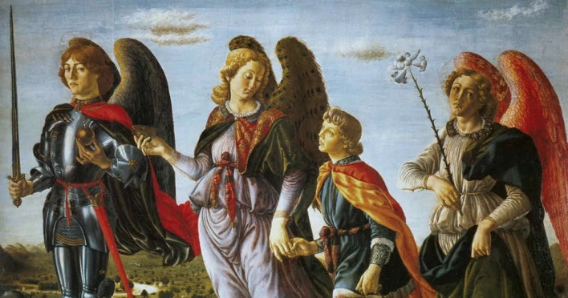  Hymns are in the New English Hymnal  465, 338, 374, 55  Gluten free hosts are available from the station by the Lady Chapel  Please take this sheet home with you | 
A big thank you to everyone who helped out with the Autumn Fair, both with preparations and on the day!
Do join us for Contemplate this evening: 30 minutes’ prayer before the Blessed Sacrament.
On the feast of Corpus Christi next year (Sunday 30th May), the Bishop of Edmonton will be coming to do confirmations. If any children would like to be confirmed, please speak to Fr Ben or Tilly. For any adults interested in confirmation and/or baptism, come and learn more about it after mass on Sunday 27th September.
There are still spaces for the day trip to the Shrine of Our Lady of Walsingham. Please speak to the clergy if you’d like to join.
Book club will be reading Story of a Soul by St. Thérèse of Lisieux. It will take place on Monday 5th October, 9th November and 7th December at the Vicarage. Her feast day is the 1st October- all are very welcome at mass!
Very sadly the Statue of Our Lady was damaged during the Assumption procession and we will need to buy a new one. If anybody would like to donate towards the cost of buying a new statue, we would be very grateful. Many thanks to Delia for loaning us an interim statue.
On Sunday 4th October, after mass, we will be holding our ecumenical Harvest Festival lunch in church. We would gratefully receive help with providing food. If you would like to contribute, please speak to Vilma.
We are holding two concerts before Christmas, on 25th October at 5pm solo Bach suites with Gamaliel Rendle Traynor and on Sunday 29th November at 3pm Music for Advent with Nina.
This Week
All services are at Holy Innocents unless stated

Monday 28th September
10.00am Mass

Tuesday 29th September: Feast of SS. Michael, Gabriel, Raphael, Archangels
9.30am Little Innocents Stay and Play
7:30pm Mass at Holy Trinity
Wednesday 30th September: St. Jerome
10:00am Mass
10.30-11.30 Coffee Morning

Thursday 1st October: St Thérèse of the Child Jesus (Thérèse of Lisieux)
7.00pm: Mass

Friday 2nd October: The Holy Guardian Angels
10.00am Mass at Holy Trinity

Saturday 3rd October
10:00am Mass with Prayer Circle

Sunday 4^{h} September: Harvest Festival
10:00am Sung Parish Mass followed by ecumenical lunch.
5.00pm Contemplate
PLEASE PRAY FOR
Those who are sick, including: Lorraine, Maurice, Joanne, Ruth, Alicia, Anthony, Steve, Leanne, Elaine, Tara, Kaleb, Mthr Roxanne, Fr Luke, Delroy, Mary, Natalie, Maureen, Maxine, Natasha, Natalie, Peter, Margaret, Pam, Kit, Gemma, Lee, Hector, Brenda, Linnette, Darren, Jaspar, Doris, Sandra, Natalie, Elaine, Thomas and Malachi.

Those who have recently died, including Barbara Edwards and Sola Adekoya.
Those whose anniversary of death occurs around this time including: Floyd Anderson, Fr. John Brownsell, Everard Brown Bishop Brian Masters, Lilly Latter and Caroline Bryan
CONTACT US
Fr Ben Kerridge Vicar 020 8340 1300 frben.holyinnocents@gmail.com The Vicarage, 99 Hillfield Av, N8 7DG
Mthr. Patricia Curate 07542 551602 mthrpatricia@holyinnocentshornsey.co.uk
Mthr. Sofia, Curate 07767 795607. curate@holyinnocentshornsey.co.uk
Brenda Barwick Lay Reader 020 8340 5382 brenda.barwick01@btinternet.com
Yvonne Westcarr Treasurer 07877403439 bookings@holyinnocentshornsey.co.uk
Website:www.holy-innocents.org.uk Facebook: www.facebook.com/HolyInnocentsN8 Instagram: holyinnocents4

